Deliverable 2: Proof of Concept Implementation

David Andrejsin
University of the Cumberlands
MSCS-532-B01: Algorithms and Data Structures
Dr. Brandon Bass
November 16, 2025

Deliverable 2: Proof of Concept Implementation

Implementation Overview
This report documents the partial implementation of a terminal-based tea recommendation system designed as part of a data structures course project. The goal of this system is to recommend tea products to users based on their preferences and interaction history. The application is implemented entirely in Python using dataclasses and fundamental data structures like sets and dictionaries for efficiency and simplicity. At this stage, the system comprises three core modules: a structured tea dataset, a Tea class, and a Customer class.
The tea dataset (RAW_TEAS) was carefully curated and normalized from publicly available information provided by The Tea Spot, a reputable online tea vendor (The Tea Spot, n.d.). The raw data represents a combination of their green and black tea offerings and includes a few key attributes such as origin countries, flavor profiles, health benefits, and caffeine content. For consistency and to ensure future compatibility with user preference tracking, flavors and benefits were normalized using set structures.
The Tea class serves as the blueprint for individual tea items. It is implemented using Python’s @dataclass decorator, which minimizes boilerplate code while providing clear structure. Key attributes include tea_id, name, kind, countries, flavors, benefits, and caffeine, with sets used for countries, flavors, and benefits to optimize lookups and avoid duplicates. A code snippet from the tea.py module illustrates this:
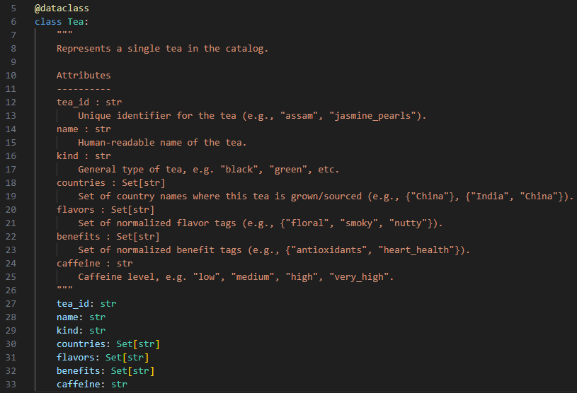
The Customer class plays a critical role in capturing user preferences and behaviors. It is designed to accumulate weighted preferences through three primary interactions: completing a preference survey, viewing a tea, or purchasing one. The preferences are tracked across five categories—countries, kinds, flavors, benefits, and caffeine levels, each stored as a dictionary mapping values to accumulated weight scores.
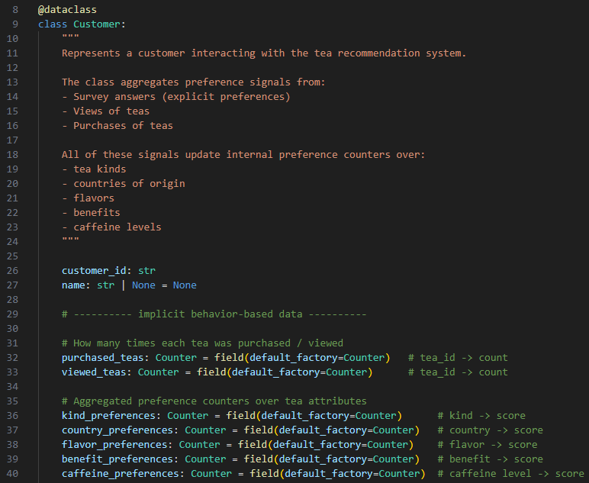
This design ensures a scalable and explainable model for building a personalized recommendation engine that responds to implicit and explicit user feedback. Peer-reviewed literature supports this approach, showing that even lightweight recommender models that track categorical preferences through weighting can outperform complex black-box models in cold-start and low-data settings (Said et al., 2013).

Implementation Challenges
A major early challenge was establishing a consistent and usable format for the tea dataset. The raw information collected from the vendor included inconsistent phrasing and mixed terminology for both benefits and flavors. To enable effective lookups and allow for simple matching with user preferences, we implemented a normalization process. For example, multiple variations such as "rich in antioxidants" and "antioxidant powerhouse" were unified under the standard "antioxidants" tag.
Additionally, flavor descriptors were reviewed for semantic redundancy. Single-use or overly specific descriptors like "pine" were grouped under broader tags such as "smoky" where appropriate. This not only improved dataset consistency but also reduced the complexity of the recommendation logic by reducing the number of unique tags the model must consider. These choices align with research highlighting the importance of tag normalization in improving the quality and interpretability of content-based recommendation systems (Tso-Sutter et al., 2008).
Another challenge involved selecting appropriate data structures for storing user preference weights. Dictionaries with integer counters were chosen over lists or tuples due to their superior time complexity for updates and lookups, especially important when many interactions accumulate over time. Furthermore, using sets for storing tea attributes (as seen in the Tea class) helped simplify matching operations and reduce memory usage—an important consideration for command-line tools with no GUI or external database integration.

Next Steps
With the foundational data structures in place, the next step is to implement the recommendation algorithm. This algorithm will compute a match score between each tea and the customer’s accumulated preferences by summing the weights associated with overlapping attributes. For instance, if a user heavily favors teas from "Japan" and "green" teas, a high score will be assigned to teas meeting both criteria.
Each type of user interaction contributes differently to preference formation. Based on earlier design choices, survey responses will contribute a weight of +10 per selected attribute, tea views will contribute +1, and purchases will contribute +5. These weights are adjustable constants and may be tuned based on testing. Once scoring is implemented, the application will rank available teas by score and present top recommendations.
The final deliverable will also include a demonstration script (main.py) that simulates interaction scenarios such as:
- A user completing the initial survey.
- Viewing multiple teas.
- Purchasing tea.
- Requesting a recommendation.
This will validate the recommendation logic in a reproducible and deterministic setting, without the need for web interfaces or real-time user input. The use of a command-line interface is deliberate, reflecting course constraints and focusing attention on the implementation of underlying data structures and algorithms.
Research into content-based recommender systems suggests that even simple interaction-based preference modeling can result in meaningful personalization, especially when users have strong categorical preferences like flavor or caffeine level (Adomavicius & Tuzhilin, 2005). Our use of a weighted preference profile aligns with this principle, offering a transparent and intuitive mechanism for tracking user taste.

References
Adomavicius, G., & Tuzhilin, A. (2005). Toward the next generation of recommender systems: A survey of the state-of-the-art and possible extensions. IEEE Transactions on Knowledge and Data Engineering, 17(6), 734–749. https://doi.org/10.1109/TKDE.2005.99
Said, A., Jain, B. J., & Albayrak, S. (2013). Analyzing weighting schemes in collaborative filtering: Cold start, post cold start and long-tail recommendation scenarios. Proceedings of the ACM RecSys '13, 241–244. https://doi.org/10.1145/2507157.2507174
Tso-Sutter, K. H., Marinho, L. B., & Schmidt-Thieme, L. (2008). Tag-aware recommender systems by fusion of collaborative filtering algorithms. Proceedings of the 2008 ACM Symposium on Applied Computing, 1995–1999. https://doi.org/10.1145/1363686.1364184
The Tea Spot. (n.d.). Gourmet Loose Leaf Tea. Retrieved from https://www.theteaspot.com/

